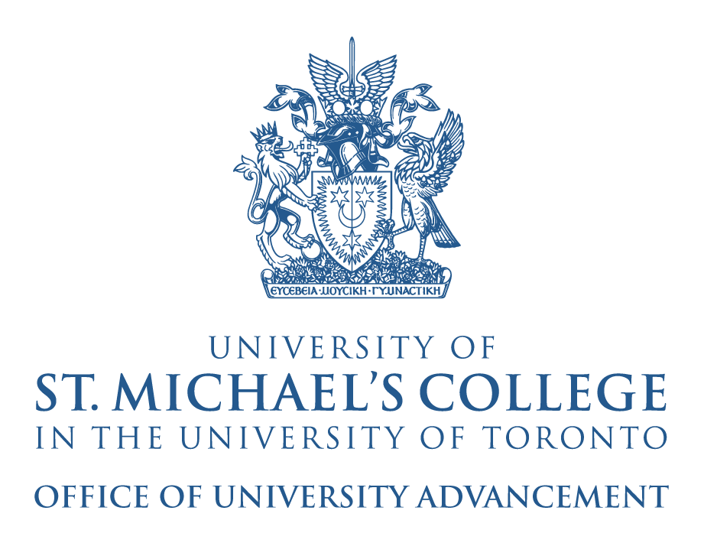

University of St. Michael’s College Young Alumni Committee Application Form

Name:

Address:

Telephone Number:

Email:

________________________________________________________________________________________________

Previous Extracurricular Experience Within the University of Toronto and St. Michael’s College

Why Do You Want to Become a Member of the Young Alumni Association?

What Initial Ideas Would You Have for Young Alumni Initiatives and Causes?

PLEASE SUBMIT THIS APPLICATION FORM WITH AN ATTACHED RESUME/CV to SMC.ALUMNIAFFAIRS@UTORONTO.CA.
ANY QUESTIONS PLEASE CONTACT THE OFFICE OF ALUMNI AFFAIRS AT 416-926-7260 OR AT SMC.ALUMNIAFFAIRS@MAIL.UTORONTO.CA

Thank you for your interest in the USMC Young Alumni Committee. Only those selected for consideration will be contacted.

